The Guarantee
Teachers have the right to teach;
Students have the right to learn.
Dear Parents,
Graphic Art is an exciting course that is a change of pace from the normal academic day. The classroom rules should serve as a guide for students and parents/guardians about grading and discipline.
Student grades will be based on a combination of in class effort and assigned projects. It is never an option to skip a project or not turn one in that is unfinished, even if the student isn’t satisfied with the result. Incomplete work may result in a failing grade unless the student has excused absences or makes up the work within one week of the close of a grading period. There is enough class time to get work finished. If a student needs extra time to complete/do work, there is open lab after school or make arrangements to come in during their study hall times. As this is s studio course, with the majority of work being done in class, students will most likely need to make up time when returning from an absence. Please review the attached grading and classroom procedures given to your student.
Any student whose disruptive behavior interferes with learning, teaching or the safety of other students will be removed from the classroom. Continued disruptive behavior will result in detention, a phone call home or referral to their administrator.
It is extremely important that your student follows classroom/equipment safety procedures. These procedures are reviewed with your student and posted in the classroom.

Quick CLASSROOM GUIDELINES
1. Follow directions the first time they are given.
2. Take care of ALL art materials (and school facility). Use tools as demonstrated. Respect all property.
3. Keep hands, feet and objects to yourself.
4. Be to class on time--AND PREPARED WITH PENCIL. Stay in assigned seat or area unless given permission to do otherwise
5. Work QUIETLY on projects -- use time wisely . Respect others at all times
6. ALWAYS clean up after yourself.
Students who follow the rules and produce quality work are always allowed to come in my room for extra time to work during the school day. I will give most of my attention to students who are in my room to learn. Students are strongly encouraged to take advantage of open studio time during their study hall.
Every student has the right to work in a positive learning environment. If a student chooses to break a rule, the following consequences will be imposed:
1st time- Student receives a verbal warning
2nd time- Student receives a written office referral and is sent to another room for no further disruptions
3rd time- Parents will be notified after the student receives the third minor misconduct Detentions or Saturday school will be assigned for repeat offenders. Also, receives a written office referral and is sent to another room for no further disruptions.
Students will be required to make up missed work.
Severe disruption (harassment, fighting, causing harm to another student in any way, destruction of property, defiant behavior) -- student is immediately referred to the office (as per student handbook). All rules in student handbook apply.
It is expected that all art students conduct themselves appropriately at all times. The art room is a busy place that contains many breakable items and cherished projects. Your complete cooperation in all of these areas is vital to everyone’s success!
I believe that all of my communications with you will be of a positive nature. I am looking forward to working with you student and guiding them through this year. The lines of communication are always open and I encourage you to contact me with any concern or delight you may have. We are both focused on the growth and learning of your student. Your student will receive an interim report of their progress every fourth week of the nine-week grading period. This is to inform you of any problem or successes you student is having. Progress reports will go home every nine weeks. You can learn about what is happening in your student’s class by accessing the West Jefferson Home page http://www.west-jefferson.k12.oh.us/. Click on classroom pages to find my name. Please feel free to call me or Mr. Young at 879 7681 x2212 or e-mail at jyoung@west-jefferson.k12.oh.us or agravlin@west-jefferson.k12.oh.us
Thank you for your support. Together, we can make this a terrific experience! Please sign the form below and return it with your son or daughter as soon as possible. Your child must return the form.
Sincerely,

Amy Gravlin Jeff Young
WJHS WJHS
Art Educator Technology Educator
Graphic Art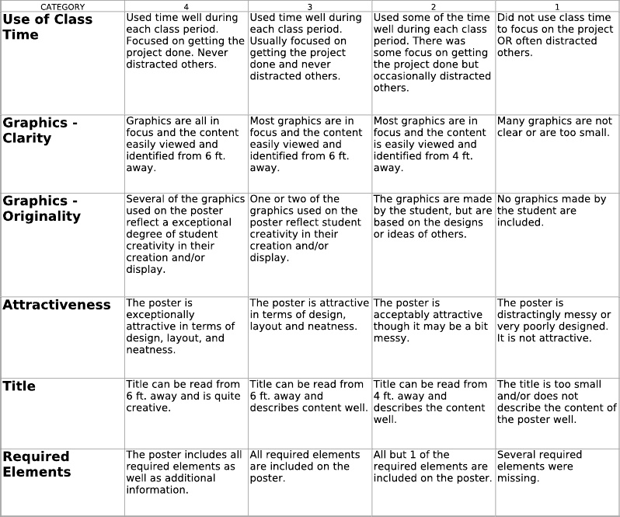

Mrs. Gravlin
Art

I have read and understand all guidelines and procedures!
Student's name____________________________ period_______ homeroom teacher____________
I have read your Classroom Discipline Plan and discussed it with my child.
Student signature ________________________________________________________
Parent/Guardian Signature_________________________________Date_______________

Parents Names______________________________________________________________________
Address _______________________________________ Phone Number______________________
Work Number____________________________________
Cell Number___________________________________

*******
I DO NOT want my child’s art work on the Internet_____________________________________
If your child has permission to have their work the Internet, Do Not sign above, the assumption will be made that he or she may have work displayed on line . Understand however, it is impossible for me to show-case every child’s work on the school site: Artsonia.com

